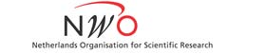
Netherlands (NWO)

For all T-AP DiD applicants based in the Netherlands.

The maximum amount of funding requested per project may not exceed €125.000 (including bench fee, if applicable).

A) Staff budget (please specify)

Type of researcher | Number | period in years | Fte
Postdoc (maximum 3 years)
HBO

B) Material costs (please specify)

Year | Equipment | Travel costs | Other costs | Total (€)
2017
2018
2019
2020
Total (€)

C) Overview NWO budget

Total (€)
Total staff budget
Total material costs
Total (€)

