Field Mapping:
An Archiving Protocol for Social Science Research Findings

MARCH 2017

Digging into Data Challenge 2013 (Round 3) Final Report

By: Frank Bosco, Sven Kepes, Mike McDaniel (United States)
Piers Steel, Krista Uggerslev (Canada)
Field Mapping: An Archiving Protocol for Social Science Research Findings – Final Report 2013
Overview of the Project
One of the greatest challenges and opportunities in the information age is making sense and making use of a vast sea of scientific research findings. In today’s “big data” era, global scientific output doubles roughly every nine years, and we need a better way to organize, accumulate, enhance, analyze, and interpret our growing corpus of amassed scientific research findings. Responding to this need, funding from the 2013 Digging into Data Challenge enabled us to build a web-based Big Science platform, which we now call metaBUS. The metaBUS platform is capable of finding and curating—as well as instantly meta-analyzing—millions of scientific research findings for broad scientific and public use (see www.metaBUS.org). Thus, metaBUS can be considered the quantitative scientific counterpart to the narrative research summaries reported in Wikipedia. Our goal is ambitious: to construct the most comprehensive search engine of cross-disciplinary scientific findings on the planet.
The problem: Current publically available scholarly search engines (e.g., Google Scholar, Web of Science) enable searching of scientific articles based on an article’s components: keywords, titles, authors, journal names, and abstracts. But critically, search results never present or summarize the actual research findings contained in the articles. Even existing institutionally accessed search engines (e.g., EBSCO, ProQuest), are often incomplete and, if the end user’s goal is to collect and interpret scientific findings on a particular topic, then a massive hand-culling and coding of hundreds (or even thousands) of articles is required. Then once these findings are coded, they are often quantitatively aggregated through meta-analysis—yet another arduous process that usually takes months and sometimes years to complete and publish. Despite the required effort, meta-analyses are conducted across a large number of disciplines. Meta-analytic findings empirically demonstrate the strength of relationships or interventions found across a body of research, making meta-analysis one of the most practically accessible and useful tools for the public’s understanding of science.
Our solution: Our approach through metaBUS has been, first, to develop a hierarchical map of scientific concepts in a given field. Next, we curate that field’s research by tagging all of the research findings from every scientific article over the last 25 years (and into the future) to the map. Our interface allows for flexible searching of exact letter string matches or nodes on the map, enabling an instant identification of all scientific work from the curated corpus of data. The findings from all studies available on a topic can then be meta-analyzed in under a minute, and the user can generate other refined meta-analyses (e.g., whether results are moderated by types of samples, by year, and by country). Through a multi-institutional effort to develop metaBUS over the last five years, we have built a field map of the multidisciplinary management and applied psychology domain, with about 3,500 concepts tagged to over 1,000,000 correlational findings, which we believe to be the largest database of scientific findings in the world.
To meet the Digging into Data Challenge 2013 Final Report deliverable requirement, this report contains three sections. The first section describes the functionality of the software platform. The second section provides a brief summary of three publications produced so far as funded in part by this grant along with links to the manuscripts. The third section is a listing of the over 25 conference presentations we have produced since the onset of the Digging into Data Challenge funding, all of which acknowledge support to this project provided by the National Science Foundation (United States) and Social Sciences and Humanities Research Council (Canada). In the fourth section, we provide further information on how the project progressed over time, lessons learned and indicators of success.
1. Description of the metaBUS Functionality Built with Digging into Data Challenge Support
Over the course of the Digging into Data grant, we pursued three main bodies of work. The first was validation of a taxonomic map of the field of management. The second was a broad scale data curation effort, and the third was development of a web-based platform that would sew together a massive database of scientific findings with meta-analytic algorithms, the taxonomy, and a functional user interface. In this section, we provide a brief description of each body of work followed by an overview of the metaBUS software.
- Taxonomy refinement
We recognized in early efforts that a “field map” or taxonomy would be necessary to organize our field’s findings. Generating a search engine of science findings and tools for research synthesis requires a system of consensus classifications or equivalency of variables or concepts as measured by various items and scales (e.g., ‘job satisfaction’ may variously be called ‘satisfaction with one’s work’, ‘satisfaction – job’, ‘jsat’). At the time of data extraction from the primary studies, like variables need to be grouped according to equivalency (and distinctiveness) for future location and synthesis. Additionally, science findings vary by the specificity of what is measured, requiring a hierarchy (e.g., ‘intrinsic job satisfaction’ and ‘extrinsic job satisfaction’ are more specific categories of ‘job satisfaction’). Finally, tools to facilitate location of associated concepts are also needed (e.g., ‘job satisfaction’ may also be related to ‘career satisfaction’, ‘pay satisfaction’, and more generally, ‘satisfaction’ or ‘happiness’). Indexing systems that incorporate equivalency, hierarchy, and association (e.g., NISO standards) are made more complicated by the need to provide flexibility to accommodate multiple scientific perspectives, and to flexibly adapt as scientific thought progresses.
Prior to the onset of this Project, members of our team developed a 5,000 node taxonomic map representing the multidisciplinary domain of human resource management, organizational behavior, and applied psychology (see Bosco et al., 2015). Towards validation of this map, we involved field experts in 3 endeavors. First, following extensive pilot testing by the team and with feedback from colleagues in our personal networks, we held an alternative session at the Society for Industrial and Organizational Psychology annual meeting where attendees used the Optimal Sort card sorting platform (i.e., https://www.optimalworkshop.com/optimalsort) to categorize a series of sets of variables into clusters. Second, we held a two-day workshop with 8 experts in the field (the three initial developers of the taxonomic map: Frank Bosco, Kulraj Singh, and James Field), and Drs. Fred Oswald, Deniz Ones, Piers Steel, Krista Uggerslev, and Neil Fassina, to validate 14 branches of variables through multiple data sorts. This group is aiming to produce a publication based on the taxonomy and our taxonomic validation research. Third, we used the same sorting methodology through online involvement with the 8 previous experts and also including other experts in our field for further map refinement.
Through these efforts, we have validated the major branches of the taxonomy initially developed, and refined many of the more specific branch hierarchies into about 3,500 nodes. However, while a validated taxonomy provides a good starting point for organizing, synthesizing, and locating research, researchers and practitioners will always have different viewpoints on the equivalency and hierarchy of the concepts in our field. Accordingly, we have built several software enablements to accommodate users’ unique perspectives. Specifically, the metaBUS software enables users to add multiple branches of the taxonomy together (e.g., satisfaction and happiness), exclude terms from searches (satisfaction but not wellbeing), and exclude more specific ‘child’ branches of a concept (e.g., to exclude intrinsic and extrinsic motivation from a query on motivation).
- Data Curation Efforts
One of the main goals of the project was to enable a dramatic advance in how researchers are able to conduct meta-analyses. Rather than the traditional approach to meta-analysis wherein a research would identify a research question and then set about gathering all of the primary studies with data, and manually extracting relevant data before conducting meta-analyses – a process typically measured in months or years – we set out to curate all of the correlational effect sizes from all of the data within our field to enable meta-analyses on any topic within the field in under a minute.
Towards this end, we engaged in a massive data curation effort. Software programs were utilized and custom-developed to increase the accuracy and speed of gathering the findings from the empirical primary studies in our field. This effort was supplemented with a massive human effort to augment the correlational effect sizes with about 20 metadata points at the level of the study (publication, year), sample (location, source of the data), and variable (reliability, timing of measurement).
All told, over 25 graduate students from across Canada and the United States participated in 3 day training events with follow on weekly check ins by two doctoral coding supervisors to create the curated database primarily over two 4 month summer waves. Including the about 200,000 correlational effect sizes members of the team had curated at the onset of the project, these efforts have produced just over 1 million correlational effect sizes each augmented with 20 metadata points (i.e., over 20 million entries into the database). While we might have hoped to leverage more machine learning to facilitate these efforts, the nuances of seeking out the metadata points from various and differing places within the articles and the complexity of understanding required to tag each point of data into nodes on the taxonomy rendered significant human effort necessary.

- Software Development and Sustainability
Development of the software was one of the two most challenging aspects of this project. We embarked upon this project setting out to build something that had never been built before. There was no prototype or competing product from which to borrow ideas or share code. Rather, we had a vision: a software interface that would integrate a massive curated data corpus with an analytic engine, accessible via a visual tool (i.e., the taxonomy), and openly accessible and available through a cloud-based user interface.
Initially, we had a member of our project team with social science and computer programming expertise who lead the software development. He had intended to use programming colleagues from India to supplement his own work, but found that his contacts were writing more convoluted code and were failing to capture the essence of what the software was intended to do. We toiled for about a year and used up significant project funds struggling to determine how the pieces may fit together and be rendered for intuitive use by researchers around the world. Almost a year into the build, we ended up having a software that just wasn’t going to realize our vision. For instance, while able to conduct meta-analyses quickly, it was doing so using RAM and would crash with even two simultaneous users. We were still progressing with development work on the taxonomy, but tying even early versions into the software ended up surpassing his know-how.
We progressed with a fresh start and a new software team. While expensive, the team was able to bring into reality what we had dreamed was possible. A scalable version of the integrated software, which can store users’ analyses and searches in the system is now broadly available. During this time, however, we realized that ongoing maintenance of the software would be required (as updates to the various component software is rolled out) and as new analytics are developed in the scholarly community. To ensure that we have a system that can integrate the latest statistical techniques and manage the maintenance of the software, a member of our project team (Frank Bosco) embarked upon learning programming in R and he developed a sandbox version of our software to accommodate even the most sophisticated of science users. This version can be maintained by the project team and is also freely available through the project website.
Related in part to the challenges we faced in developing the software, the second major challenge faced by our team related to establishing a sustainability plan for the system. Early on, we recognized that realizing our vision – not to build an amazing system just for our project team, but to have it openly available to users around the world to advance science and upon which to make evidence-informed decisions – would require the system to be not only scalable (which necessitates some server and maintenance costs), but also kept current with the latest corpus of research as new findings are generated.
Significant amounts of team time have been spent scoping out various sustainability possibilities. We have found that although granting agencies are ready to fund new advances, there are substantially fewer opportunities to keep already funded initiatives up and running. Several of the sustainability possibilities we have explored led us into conversations with the multiple technology transfer offices at our various institutions as we explored setting up a not-for-profit, commercializing a practitioner-oriented interface to support open access by science users, partnering with other commercially-focused groups, and seeking a partnering foundation. Terms around intellectual property and its ownership, licensing agreements, royalty rates and so forth brought complexity the social scientists making up our research team had not anticipated. We went off in various directions taking commercialization courses through the NSF, seeking IP legal advice, and frankly, just being downright confused on how to move forward to keep the platform sustainable.
We realized that had we intended to build a great system and just publish our brains out, we would have had a much easier job on our hands! It was wanting to open up the software for all users to benefit (and to advance science and substantially reduce the wasteful redundancies going on in our field) that added a whole unforeseen tumour onto the project. Our experience has been that there is a significant deficit in the assistance available on this front. Immediately, the groups designed to help address these questions seek to claim royalties and sign agreements without a helpful and guiding hand in, what at least for us, was completely unfamiliar territory. It has taken us significant time and, in honesty, the unfamiliarity led to significant tensions at time, as we moved down the path towards sustainability. We are not fully there yet, but as a team we feel we are past the tipping point towards finding and funding our sustainable future.
- Overview of the metaBUS software
The beta version of the metaBUS software was launched in June, 2016, and is openly available at beta.metabus.org. We invite you to please visit the site for your personal user account. Next, we provide an overview of the software capabilities with screen captures.
Within the software, there are two major functions. The first function, the “locate” function, enables users to search for a term in our field by either a taxonomic node code (i.e., 5-digit unique identifier) or through a letter string query based on the taxonomic node’s text.
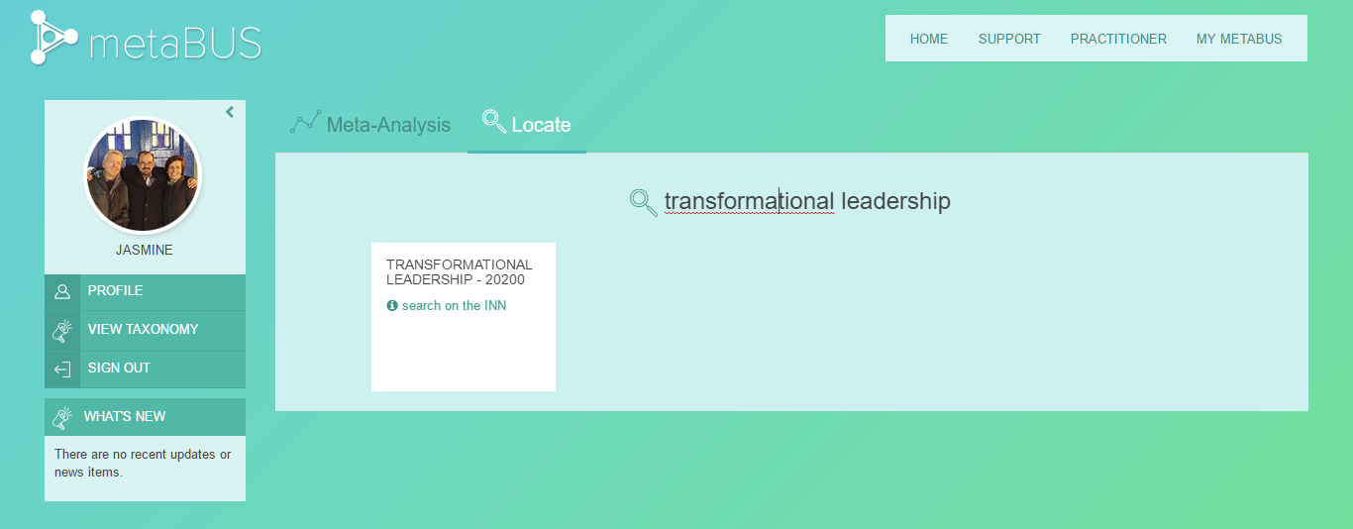
The software then returns all of the studies (from the growing corpus of curated data) that contain correlational data corresponding to that search term (currently about 1,000,000 findings from 26 journals in the HRM field). Users can generate a reference list of all of the studies with data on that topic with links to the studies themselves, and they can examine that search term in relation to all other variables the topic has been studied in relation to and sort it by strength of relationship, by frequency of co-study, alphabetically, and so on.
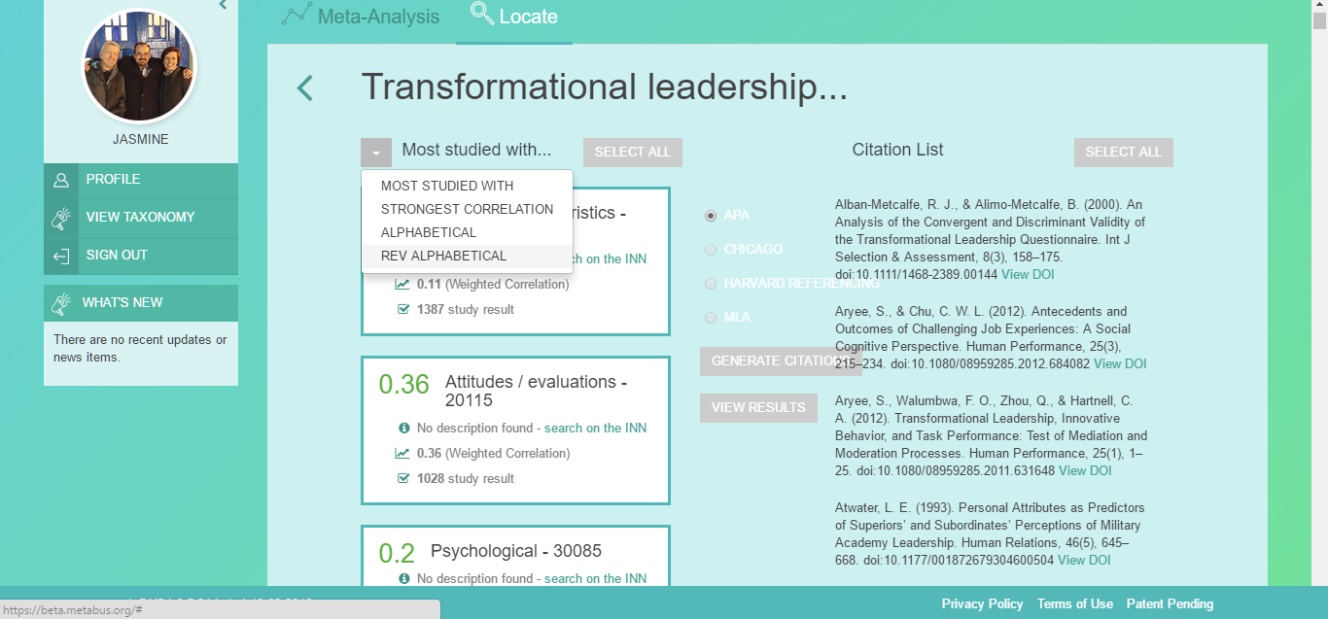
The second function, the “Meta-analysis” function, enables users to select any two concepts in our field, for instance, in the example below we have selected job satisfaction and individual performance.
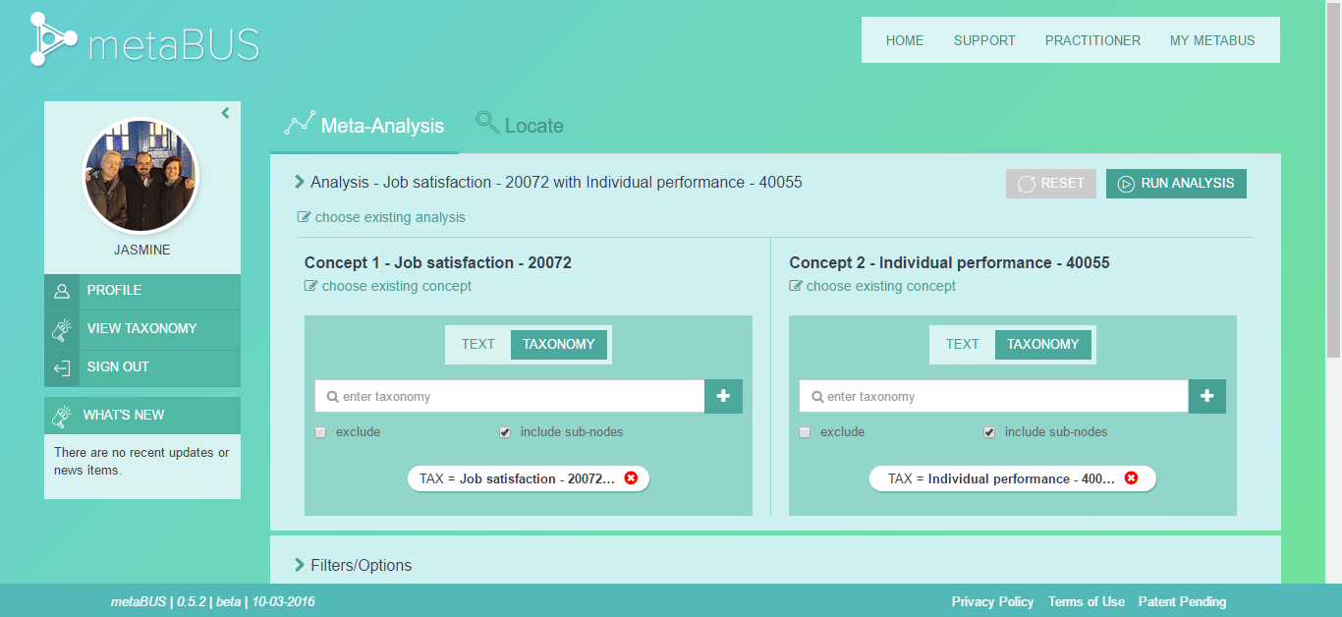

By clicking Run Analysis, users can see an instant meta-analysis of the data on that topic (from the curated corpus of data) complete with several plots and analytic options.
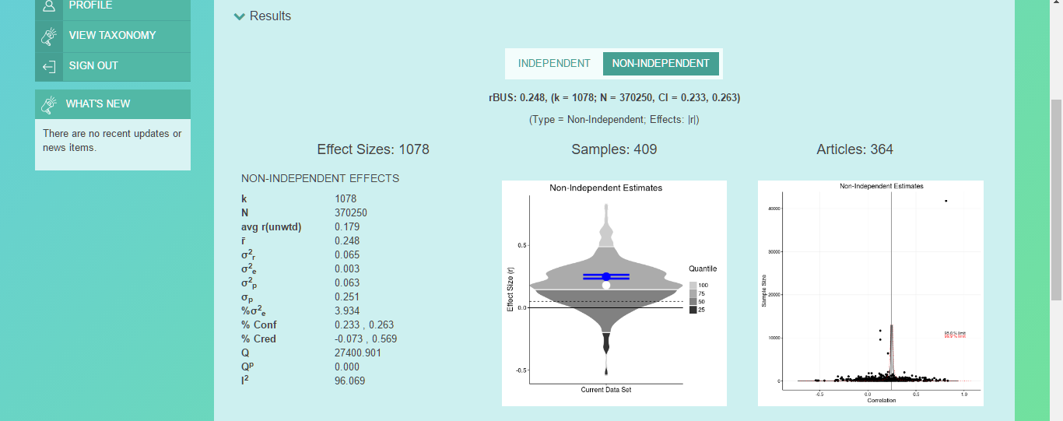

The data can be filtered on a number of criteria (such as by year, response rate, and reliability), as well as individual records can be deleted or have their valence reversed.

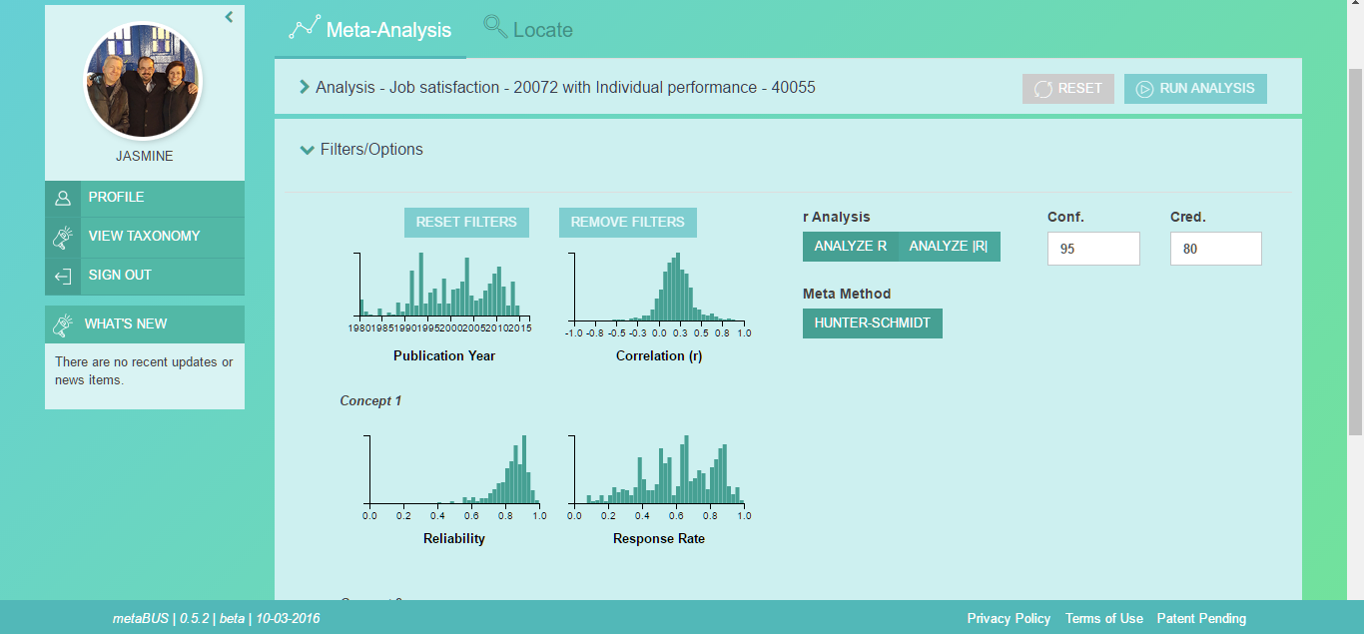

Additionally, by entering Moderator Mode, meta-analyses can be examined through a series of extant coded moderators (e.g., country, grant-funding).
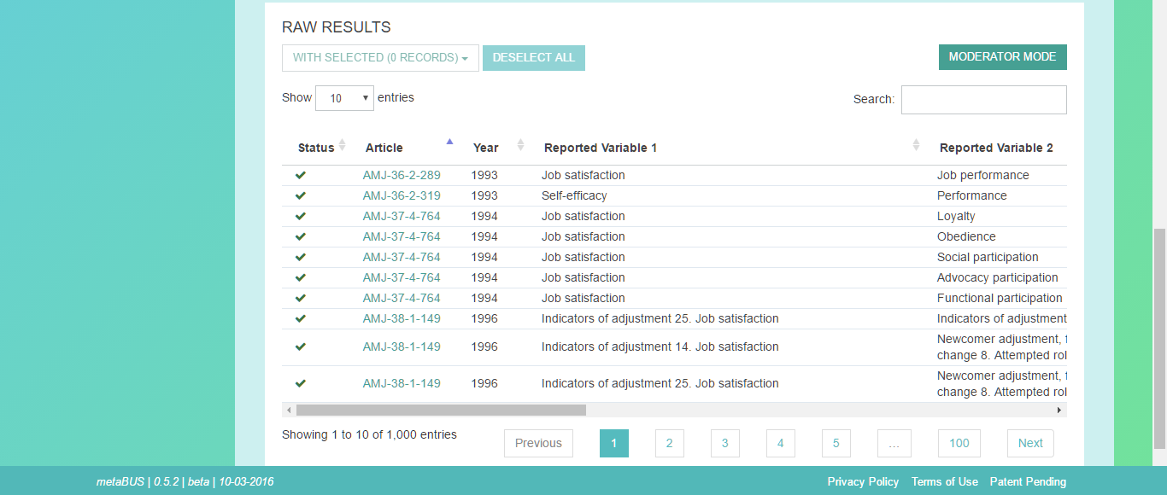

Moderator analyses can also be conducted using a user’s inputted (or custom) moderator levels.

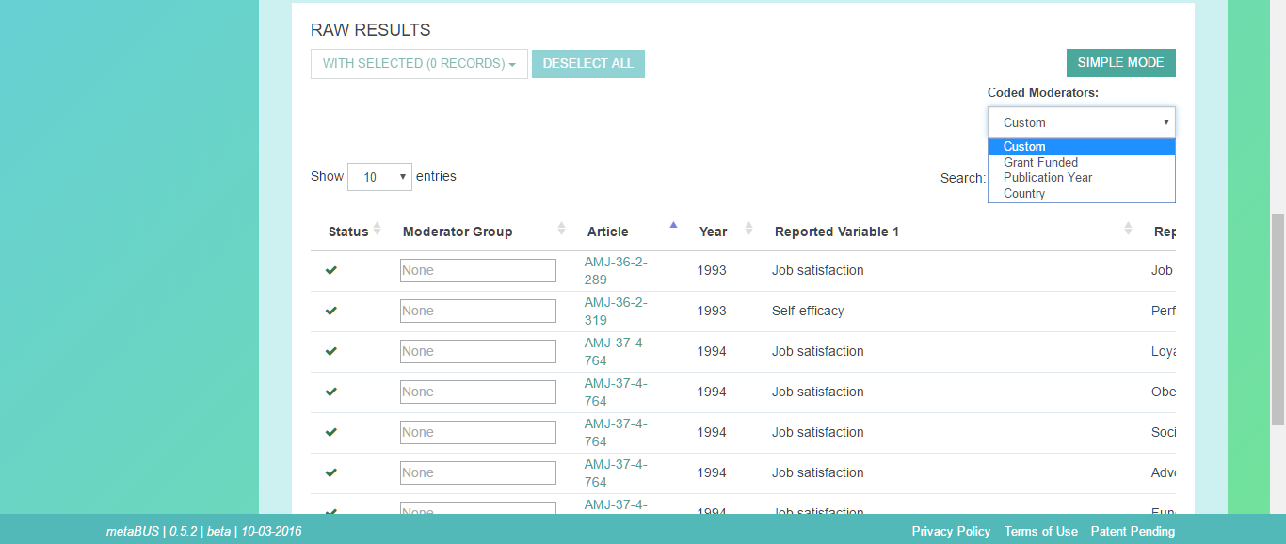

All concepts and meta-analyses can be stored within users’ personal profiles organized by custom workgroups for future use and iterative work.
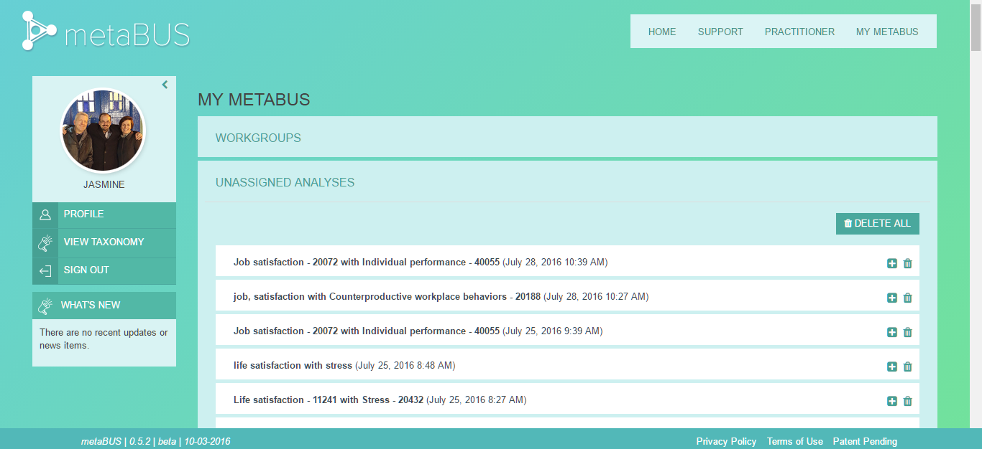

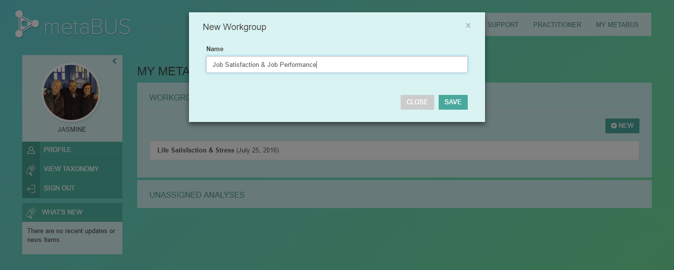
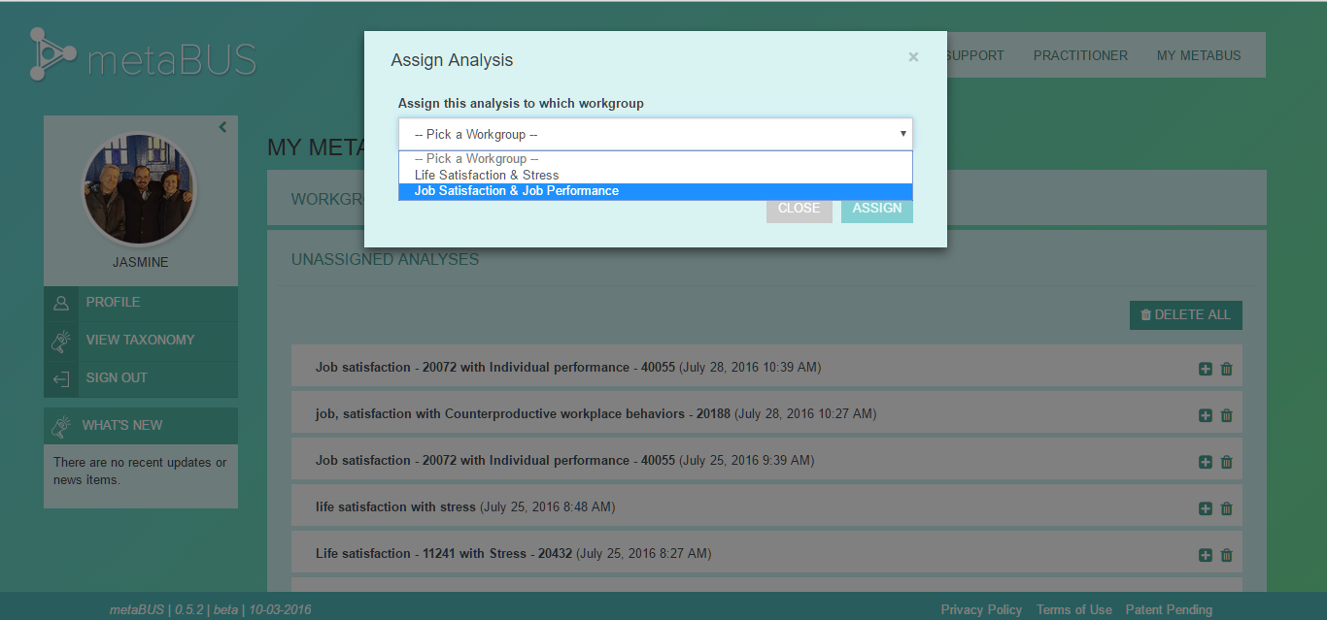

Please view the “how to” video here (https://www.youtube.com/watch?v=k9ZfpxsBmrk), and request a free user account at beta.metabus.org.
In addition to being able to email members of the team with their feedback, the metaBUS software is built with a Support function in the task menu. Users can create a ‘ticket’ directly for our software development team describing their comments and feedback from within the site. As per the world map below, thousands have accessed the metaBUS website from across the world and there are currently about 1000 registered users on the metaBUS website. We have not conducted a large-scale marketing or release of the metaBUS software; once that is done, we anticipate significant feedback leading to significant advances in the data representations offered.
For interest’s sake, the globe below depicts all of the locations in the world where users have accessed the metaBUS system.

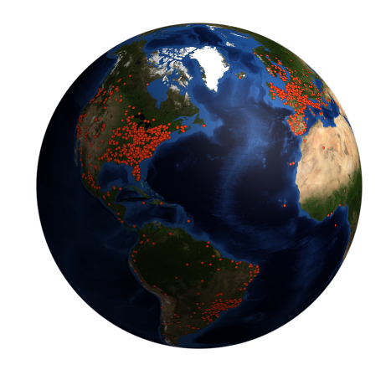
2. Publications
With grant support from the 2013 Digging into Data Challenge, we have produced the following three publications:

A. Bosco, F. A., Uggerslev, K. L., & Steel, P. (2017). metaBUS as a vehicle for facilitating meta-analysis. Human Resource Management Review, 27, 237-254.

Abstract: To address new research questions and get a clearer picture of research, scientists and practitioners in human resource management have come to rely heavily on meta-analyses. However, meta-analyses may take months or years to produce and are becoming increasingly difficult to produce as the corpus of available research grows exponentially. We describe how the metaBUS platform can assist in tackling two central challenges to conducting meta-analyses. In addition, we provide a detailed description of the platform, with information on all fields included in the database. Next, we provide recommendations for three use cases: generating literature search terms by using the metaBUS taxonomy, conducting metaBUS queries to locate findings and generate first-pass meta-analyses, and identifying relevant findings that might have gone overlooked during traditional literature searches. We demonstrate a new software and a cloud-based interface that allow users to leverage the platform. We conclude with implications, limitations, and future directions.

B. Baker, C. A., Bosco, F. A., Uggerslev, K. L., & Steel, P. (2016). metaBUS: An open search engine of I-O research findings. The Industrial-Organizational Psychologist. Available at: http://www.siop.org/tip/july16/metabus.aspx

Abstract: Social scientists are witnessing a paradigm shift in research methodology that has vast implications for the understanding and application of I-O research. This new zeitgeist has emerged concomitantly with advances in accessibility (e.g., cloud-based computing), scale (e.g., big data), and considerable introspection regarding research claims (e.g., lack of trustworthiness, Kepes & McDaniel, 2013; reproducibility, Klein et al., 2014) as well as how research should be conducted (e.g., appropriateness of inductive vs. deductive inference; Colberg, Nester, & Trattner, 1985). In this article, we describe a new open-access research tool called metaBUS (http://metaBUS.org), a search engine of currently more than 800,000 research findings that facilitates the location, summarization, and communication of a large corpus of I-O research. A short video tutorial of the metaBUS beta platform can be found here. - See more at: http://www.siop.org/tip/july16/metabus.aspx#sthash.kK2Nrvj1.dpuf

C. Bosco, F. A., Steel, P., Oswald, F. L., Uggerslev, K. L., & Field, J. G. (2015). Cloud-based meta-analysis to bridge science and practice: Welcome to metaBUS. Personnel Assessment and Decisions, 1, 3-17.

Abstract: Although volumes have been written on spanning the science–practice gap in applied psychology, surprisingly few tangible components of that bridge have actually been constructed. We describe the metaBUS platform that addresses 3 challenges of one gap contributor: information overload. In particular, we describe challenges stemming from: (a) lack of access to research findings, (b) lack of an organizing map of topics studied, and (c) lack of interpretation guidelines for research findings. For each challenge, we show how metaBUS, which provides an advanced search and synthesis engine of currently more than 780,000 findings from 9,000 studies, can provide the building blocks needed to move beyond engineering design phase and toward construction, generating rapid, first-pass meta-analyses on virtually any topic to inform both research and practice. We provide an Internet link to access a preliminary version of the metaBUS interface and provide 2 brief demonstrations illustrating its functionality.

As evidenced from the list of conference presentations in the next section, we have a number of additional projects initiated during the window of funding support from the Digging into Data Challenge, and as such, all acknowledge this funding support.
3. Presentations
Since the funding announcement from the Digging into Data Challenge in 2013, we have conducted over 25 presentations acknowledging this research support.

2017
Bosco, F. A., Landis, R., Kepes, S., Uggerslev, K. L., Steel, P., & Brooks, P. (2017, April). Dimension reduction as a vehicle for assessing construct redundancy. In. G. Howardson (Chair), Contemporary Views and Methods for Dimension Reduction. SIOP symposium (SIOP submission #51788; April 29 8:00-9:30AM, Room N. Hemisphere E2).

Holland, S., Green, J., Markell, H. M., & Bosco, F. A. (2017, April). R Shiny: Using apps to support I/O research. SIOP Master Tutorial (SIOP submission #51282; April 29 10:00-11:30AM, Room N. Hemisphere A3).

Khosravi, J., Lee, C., Bosco, F. A., & Steel, P. (2017, April). Using new metaBUS functions to facilitate systematic reviews and meta-analyses. SIOP Master Tutorial (SIOP submission #51370; April 29 3:00-4:30PM, Room Asia 4 — part of an all-day Reproducible Research [RR] Theme Track).

Bosco, F. A., Field, J. G., Uggerslev, K. L., & Steel, P. S. (2017, March). Introducing metaBUS. March 22-25, Vienna, Austria.

2016
Field, J. G. (2016, October). How open-access to big data can narrow the science-practice gap: A demonstration of the metaBUS platform. Brown bag seminar and workshop held at the George Mason University Department of Psychology, Fairfax, VA.

Uggerslev, K. L., Hambley, L., Bosco, F. A., & Steel, P. (2016, October). Estimating the relative importance of competencies associated with talent potential and performance. Paper presented at the 5th annual Workshop on Talent Management for the European Institute for Advanced Studies in Management. Copenhagen, Denmark.

Steel, P., Field, J. G., Bosco, F. A., & Uggerslev, K. L. (2016, August). Generating instant custom meta-analyses: A metaBUS tutorial for synthesizing management research. Professional Development Workshop to be held at the meeting of the Academy of Management, Anaheim, CA.
Steel, P., Uggerslev, K. L., & Bosco, F. A. (2016, June). metaBUS. Presentation and community launch of the first steps towards a practitioner interface. Haskayne School of Business downtown campus, Calgary, Canada.
Steel, P., Uggerslev, K. L., & Bosco, F. A. (2016, June). metaBUS. Presentation and launch of the academic metaBUS interface. University of Calgary, Canada.
Bosco, F. A., Uggerslev, K. L., & Steel, P. (2016, May). metaBUS as a vehicle for investigating construct redundancy. Invited guest presentation for the Personnel and Human Resources Research Group (PHRRG).
Steel, P., Bosco, F. A., & Uggerslev, K. L., (2016, May). The metaBUS Project: Large-scale curation of scientific findings for research synthesis. Invited presentation for the Department of Psychology, University of Minnesota.
Field, J. G., Baker, C. A., Bosco, F. A., McDaniel, M. A., & Kepes, S. (2016, April). The extent of p-hacking in I-O psychology. Paper presented at the meeting of the Society for Industrial and Organizational Psychology, Anaheim, CA.
Uggerslev, K. L., Bosco, F. A., Steel, P., & Field, J. G., (2016, April). Using metaBUS for literature searches and generating instant meta-analyses. Master tutorial presented at the meeting of the Society for Industrial and Organizational Psychology, Anaheim, CA.
Zhang, Y., Khosravi, J. Y., Arnold, C. B., Bosco, F. A., Uggerslev, K. L., & Steel, P. (2016, April). Predicting employee outcomes with different measures of workload. Paper presented at the meeting of the Society for Industrial and Organizational Psychology, Anaheim, CA.
Bosco, F. A., Steel, P., & Uggerslev, K. L., (2016, March). Cloud-based curation of scientific findings. Invited presentation and workshop held at Leeds School of Business, University of Colorado Boulder.
Uggerslev, K.L., Bosco, F. A., & Steel, P.S. (2016, February). metaBUS: Cloud-based curation of research findings in management. Invited presentation at the Alberta Innovates Centre for Machine Learning.
Bosco, F. A., Steel, P.S., Uggerslev, K. L., McDaniel, M., & Kepes, S. (January, 2016). metaBUS: Tools for finding, curating, synthesizing, and disseminating scientific research. 2013 Transatlantic Digging Into Data Challenge Final Conference. Glasgow, Scotland.
2015
Bosco, F. A., Aguinis, H., Uggerslev, K. L., Steel, P., Singh, K., & Pierce, C. A. (2015, August). The one-minute meta-analyst: A metaBUS tutorial for synthesizing management research. Preconference development workshop held at the meeting of the Academy of Management, Vancouver, BC.
Bosco, F. A., Uggerslev, K. L., & Steel, P. G. (2015, August). metaBUS: Tools and techniques for Big Data analytics. In R. Piccolo & C. Beungeler (Chairs), Big Data in team research: Applications, techniques, and implications. Symposium held at the meeting of the Academy of Management, Vancouver, BC.
Field, J. G., Mihm, D. C., O’ Boyle, E. H., Bosco, F. A., Uggerslev, K. L., Steel, P. (2015, August). An examination of the funding-finding relation in the field of management. Paper presented at the meeting of the Academy of Management, Vancouver, BC.
Bosco, F. A., Uggerslev, K. L., Steel, P., Aguinis, H., Field, J. G., Pierce, C. A., Munc, A. H., Daniel, J. M., Allen, D. A., Widlak, I., Sarkar-Barney, S. T., & Sriram, N. (2015, April). Using science-mapping and meta-analysis to bridge the scientist-practitioner divide. Alternative session presented at the meeting of the Society for Industrial and Organizational Psychology, Philadelphia, PA.
Bosco, F. A., Aguinis, H., Field, J. G., Pierce, C. A., & Munc, A. (2015, April). Not all measures created equal: Reliability heterogeneity in I-O domains.
Daniel, J. M., & Allen, D. G. (2015, April). Translating I-O and HR research into practice: Challenges and opportunities.
Uggerslev, K. L. (2015, April). metaBUS: A tool for translating research findings into practical use.
Sriram, N. (2015, April). Constructing consensus classifications.
Steel, P. (2015, April). New analytic capacity.
Widlak, I., & Sarkar-Barney, S. (2015, April). Making meta-analytic findings actionable.
Bosco, F. A., Uggerslev, K. L., Steel, P., & Field, J. G. (2015, April). Generating instant meta-analyses using the metaBUS database and construct taxonomy. Master tutorial presented at the meeting of the Society for Industrial and Organizational Psychology, Philadelphia, PA.

Field, J. G., Munc, A. H., Bosco, F. A., Uggerslev, K. L., & Steel, P. (2015, April). Effect size benchmarks for common I-O topics around the globe. Paper presented at the meeting of the Society for Industrial and Organizational Psychology, Philadelphia, PA.
*Selected as SIOP 2015 Best International Poster.

Bosco, F. A. (2015, February). metaBUS: Tools for the curation, analysis, and dissemination of scientific research. Invited presentation for Richmond IEEE.

2014
Bosco, F. A. (2014, October). metaBUS as a vehicle for curating and communicating HR research findings. Brown bag seminar held at HumRRO, Alexandria, VA.
Bosco, F. A., Uggerslev, K. L., & Steel, P. (2014, October). Scientific findings as Big Data for research synthesis: The metaBUS project. Paper presented at the IEEE International Conference on Big Data, Washington, DC.

Bosco, F. A. (2014, September). Mapping management findings in hopes of eventually making sense to others… and ourselves. Presentation for Dean’s Seminar Series, VCU School of Business, Richmond, VA.
In F. A. Bosco & P. Steel (Chairs), The “big science” revolution in management: Possibilities, technology, and applications. Symposium conducted at the meeting of the Academy of Management, Philadelphia, PA:
Bosco, F. A., Aguinis, H., Kepes, S., Gabriel, A. S., & Field, J. G. (2014, August). Assessing the impact of nonresponse bias: A “big science” approach.
Uggerslev, K. L., Bosco, F. A., & Steel, P. (2014, August). Imagining the possibilities of “big science”: The case of field mapping and real-time meta-analysis.
Sriram, N., & Nosek, B. (2014, August). A collaborative, standards-based international participant pool.
Steel, P. (2014, August). Mapping the nomological web of the social sciences.
Bosco, F. A., Uggerslev, K. L., Steel, P., & Kepes, S. (2014, July). Toward a field map for managing big data in personnel assessment. Paper presented at the meeting of the International Personnel Assessment Council, Denver, CO.
4. The Unfolding of the MetaBUS Project
We kicked off the Digging into Data grant with a face-to-face meeting with three members of the project team (Frank Bosco, Piers Steel, and Krista Uggerslev) and our initial software development lead in December 2013. With assistance from a Project Manager provided through the Canadian Centre for Advanced Studies in Leadership (CCAL) at the University of Calgary, we embarked upon a 2 day session organizing the components of the project, setting component leads, schedule, targets, and so forth. At the outset, this served us well to begin to establish roles and responsibilities, how the pieces of the project would need to come together, and to put some timelines onto the project. We had the chance to flesh out some details and recognize areas where we still had some uncertainties; this session served us very well and began to establish project management processes that we would engage in throughout the project.
We set up weekly meetings to be conducted using Google Hangouts. Over time, we had two project managers who sat with us during our busiest times who set our agendas, and took notes of the deliverables, objectives, leads, and timelines. In short order, it came to be that there were three of us who really shared the responsibility and vision for shaping the next steps of the project and building the vision. During these weekly meetings (some of which surpassed the 5 hour mark!), we debated aspects of science, such as analytic methods to embed and how to organize the taxonomy, hired coding supervisors and a coding team, pursued many granting opportunities, supervised and provided continual feedback to our software team (who were trying to build software serving the visions of three different project leads), waded through sustainability options, engaged our advisory team, built websites and made project videos, sought all sorts of subject matter expertise, dealt with administrative aspects associated with hiring and paying more than 30 students and contractors to work on the project, and planned research papers and presentations. We created a Dropbox repository for our project materials, and have probably had only a handful of days in the last 3 years where we haven’t been in touch via email.
The project team met typically twice per year in conjunction with conferences, and had two additional face-to-face meetings (one in Edmonton, and the DiD wrap-up conference in Scotland). These face-to-face meetings became the opportunity for us to intensively work on the project, and also to bond. Without a doubt, the project blossomed to be significantly more effort than we would have anticipated upon submission of the DiD application in 2013. It also came with many more obstacles to be overcome. We were moving into uncharted territory and trying to build something that one granting body provided feedback on as “an incredible idea”, but “unfeasible”.
Now, it is extremely pleasing to have the system working, and significantly advancing the speed of science. Along the way, we realized that what we were building was not just a tool for data synthesis, but also a tool that would enable a user to locate all empirical findings on their topic of interest. In short, the scope of the project grew along with the user problems it was able to solve. We are only now embarking on integrating feedback from users into the system. We still have some articles to code to make our data corpus complete, and although we have taken strides towards sustainability, we are not complete yet. Feedback from participants at conferences and our user base would suggest that we have built a tool that is changing the face of science in our discipline. We have broken down barriers with respect to collaboration (rather than competition) and have been joined by other contributors from around the world to develop next steps.
Conclusion
The metaBUS project is an ongoing one with broad aims to (a) advance the speed of science, (b) enable evidence-based practice, and (c) foster the public understanding of science. The Project funding provided to the metaBUS project by the 2013 Digging into Data Challenge was absolutely pivotal in making the open release of the metaBUS software come to fruition. Towards the goals set out in our project proposal, we have been successful in taking broad steps forward because of the funding provided by SSHRC and NSF, and we look forward to moving further down the path towards advancing practice as the metaBUS project continues to evolve.
To advance evidence-based practice further, we envision a number of next steps that involve adding a substantial number of collaborators to the project. We seek to significantly extend the cloud-based metaBUS data location and meta-analysis tools to: (a) substantially add to the curated data fundament of currently over 1,000,000 quantitative findings from 10,000 articles (U.K., U.S.), (b) develop protocols for curation of qualitative findings (U.K.), (c) write meta-analytic software algorithms for Big Data (Netherlands), (d) develop cloud-based taxonomy building protocols for easily locating and synthesizing research findings (Germany), (e) build crowd coded data integration capabilities (Canada), (f) advance data curation speed through machine learning (Canada), and (g) create data source linkages that complement and enhance existing open science projects (U.S.). Additionally, we seek to use the platform to address four sets of research questions, and meet goals of accelerating the speed of science, fostering evidence-based practice, and facilitating the public understanding of science.

Appendix A – Coded Articles by Journal and Year
 | 1980-1989 | 1990 | 1991 | 1992 | 1993 | 1994 | 1995 | 1996 | 1997 | 1998 | 1999 | 2000 | 2001 | 2002 | 2003 | 2004 | 2005 | 2006 | 2007 | 2008 | 2009
AJOP | -- | -- | -- | -- | -- | -- | -- | -- | -- | -- | -- | -- | -- | -- | -- | -- | -- | -- | -- | 2 | 4
AMJ | -- | 12 | 14 | -- | 45 | 41 | 43 | 42 | 30 | 31 | 34 | 54 | 41 | 54 | 37 | 36 | 50 | 41 | 48 | 49 | 44
BJM | -- | -- | -- | -- | -- | -- | -- | -- | -- | -- | 7 | 4 | 5 | 4 | 1 | 6 | -- | 10 | 11 | 11 | 20
ERRJ | -- | -- | 3 | 2 | 4 | 1 | 2 | 3 | 4 | -- | -- | 2 | 3 | -- | 2 | 2 | 2 | 1 | 3 | 4 | 2
EWOP | -- | -- | -- | -- | 7 | 4 | -- | 2 | 1 | 4 | 6 | 5 | 14 | 8 | 10 | 12 | 15 | 16 | 12 | 19 | 15
GOM | -- | 18 | 15 | 16 | 20 | 14 | 12 | 13 | 8 | 8 | 16 | 8 | 17 | 10 | 10 | 18 | 18 | 14 | 14 | 18 | 19
HP | -- | 3 | 3 | 1 | 4 | 1 | 3 | 5 | -- | 6 | 7 | 10 | 10 | 7 | 11 | 10 | 14 | 15 | 17 | 15 | 3
HR | -- | 11 | 16 | 6 | 12 | 15 | 21 | 22 | 11 | 12 | 10 | 15 | 6 | 7 | 11 | 9 | 10 | -- | 10 | 15 | 11
HRM | -- | 3 | 1 | -- | 2 | 5 | 1 | 4 | 3 | 3 | 4 | 2 | 6 | 6 | 3 | 4 | 8 | 11 | 13 | 15 | 21
HRMJ | -- | -- | -- | -- | 1 | -- | -- | -- | 4 | 3 | -- | -- | 1 | 3 | 6 | 5 | 3 | 3 | 4 | 6 | 7
IJHRM | -- | 2 | 5 | 1 | 4 | 3 | 10 | 5 | 10 | 11 | 6 | 15 | 21 | 18 | 24 | 27 | -- | -- | 5 | 48 | 49
IJSA | -- | -- | -- | -- | 3 | 6 | 2 | 7 | 8 | 7 | 10 | 5 | 9 | 9 | 21 | 10 | 20 | 27 | 32 | 43 | 40
JAP | 64 | 7 | 7 | -- | 7 | 3 | 5 | -- | 2 | 5 | 5 | 5 | 14 | 58 | 10 | 5 | 73 | 10 | 5 | 1 | 5
JASP | -- | 19 | 22 | 8 | -- | -- | -- | -- | -- | -- | 15 | 17 | -- | 18 | 5 | 49 | 43 | 58 | 65 | 73 | 54
JBP | -- | 10 | 9 | 13 | 14 | 6 | 13 | 18 | 16 | 14 | 18 | 18 | 20 | 17 | 19 | 18 | 18 | 21 | 13 | 16 | 24
JM | -- | -- | -- | -- | -- | -- | -- | -- | -- | -- | -- | -- | -- | 8 | -- | -- | -- | 1 | 19 | 20 | 53
JMP | -- | 2 | 2 | -- | -- | -- | 4 | 6 | 6 | 5 | 12 | 16 | 14 | 14 | 18 | 19 | 18 | 21 | 19 | 25 | 30
JOB | -- | 13 | 16 | 19 | 26 | 20 | 19 | 24 | 4 | 29 | 49 | 34 | 33 | 30 | 32 | 31 | 28 | 31 | 24 | 31 | 39
JOOP | -- | 13 | 13 | 13 | 13 | 10 | 11 | 12 | 13 | 16 | 18 | 12 | 16 | 20 | 10 | 16 | 24 | 42 | 51 | 28 | 30
JPP | -- | -- | -- | -- | -- | -- | -- | -- | -- | -- | -- | -- | -- | -- | -- | -- | -- | -- | -- | -- | --
JVB | -- | 16 | 14 | 14 | 13 | 21 | 23 | 12 | 24 | 27 | 26 | 25 | 26 | 46 | 84 | 48 | 26 | 43 | 34 | 46 | 39
LQ | -- | 6 | -- | -- | -- | 2 | 7 | 1 | -- | 8 | 3 | 3 | 7 | 13 | 7 | 15 | 10 | 11 | 12 | 16 | 26
OBHDP | -- | 4 | 4 | 7 | 28 | 23 | 34 | 7 | 7 | 12 | 11 | 13 | 8 | 18 | 12 | 9 | -- | -- | -- | 13 | 22
PID | -- | 7 | -- | 9 | -- | 14 | -- | 60 | -- | -- | -- | -- | -- | -- | 38 | -- | -- | 78 | 44 | 10 | --
PPsych | 6 | 10 | -- | -- | 1 | -- | -- | 1 | 2 | 1 | 1 | 5 | 1 | 5 | 2 | 5 | 2 | -- | -- | -- | 1
WS | -- | -- | -- | -- | -- | -- | -- | -- | 11 | 7 | 14 | 9 | 16 | 11 | 6 | 10 | 8 | 9 | 11 | 14 | 17

 | 2010 | 2011 | 2012 | 2013 | 2014 | 2015 |  | Journal | Total Articles Coded in Journal
AJOP | 5 | 1 | 3 | 1 | 3 | 1 |  | The Australian and New Zealand Journal of Organisational Psychology | 20
AMJ | 33 | 36 | -- | 45 | 35 | 54 |  | Academy of Management Journal | 949
BJM | 25 | 10 | 15 | 20 | 20 | -- |  | British Journal of Management | 169
ERRJ | 4 | 5 | 3 | 2 | 7 | 4 |  | Employee Responsibilities Rights Journal | 65
EWOP | 22 | 27 | 28 | 44 | 49 | 13 |  | European Journal of Work and Organizational Psychology | 333
GOM | 14 | 12 | 17 | 17 | -- | -- |  | Group & Organization Management | 346
HP | 17 | 14 | 18 | 27 | -- | -- |  | Human Performance | 221
HR | 28 | 18 | 23 | 22 | -- | -- |  | Human Relations | 321
HRM | 26 | 17 | 23 | 30 | -- | -- |  | Human Resource Management | 211
HRMJ | 10 | 4 | 11 | 10 | -- | -- |  | Human Resource Management Journal | 81
IJHRM | 63 | 102 | 104 | 105 | 66 | 12 |  | International Journal of Human Resource Management | 716
IJSA | 64 | 27 | 29 | 14 | -- | -- |  | International Journal of Selection and Assessment | 393
JAP | 1 | 60 | 61 | 44 | 63 | 84 |  | Journal of Applied Psychology | 604
JASP | 59 | 66 | 76 | 116 | 32 | 30 |  | Journal of Applied Social Psychology | 825
JBP | 26 | 20 | 21 | 21 | 39 | 43 |  | Journal of Business Psychology | 485
JM | 22 | 11 | -- | 36 | 40 | -- |  | Journal of Management | 210
JMP | 32 | 31 | 32 | 32 | 43 | -- |  | Journal of Managerial Psychology | 401
JOB | 28 | 41 | 43 | 37 | 42 | 41 |  | Journal of Organizational Behavior | 764
JOOP | 32 | 25 | 23 | 20 | -- | 9 |  | Journal of Occupational and Organizational Psychology | 490
JPP | 13 | 12 | 11 | 14 | 13 | 12 |  | Journal of Personnel Psychology | 75
JVB | 64 | 64 | 76 | 54 | 61 | 72 |  | Journal of Vocational Behavior | 998
LQ | 32 | 39 | 37 | 32 | 36 | -- |  | The Leadership Quarterly | 323
OBHDP | 17 | 32 | 25 | 28 | -- | -- |  | Organizational Behavior and Human Decision Processes | 334
PID | 9 | 26 | 17 | -- | 5 | 88 |  | Personality and Individual Differences | 405
PPsych | -- | 15 | 15 | 19 | -- | 19 |  | Personnel Psychology | 111
WS | 9 | 14 | 15 | 14 | 1 | 11 |  | Work & Stress | 207

